AEO “Nazarbayev Intellectual Schools”

CHEMISTRY Grade 12

Paper 2 May 2022

MARK SCHEME

Maximum Mark: 100

PRE-STANDARDISATION
Question | Answer | Mark | Additional guidance
1(a) (i) | Different number / amount of neutrons/ different mass numbers/ different number of subatomic particles in the nucleus | [1] | Not different neutrons  Ignore same protons and/or electrons
1(a) (ii) | ²⁷₁₃Al | [1] | Accept ²⁷Al / Al
1(a) (iii) | RAM = (124 x 63) + (56 x 65)  (124 + 56)  RAM = 63.6 | 1  1  [2] | Note  Award only 1 mark for correct calculation without correct decimal place/ for stating correct decimal place without calculation
1(b) | Al(g) -→ Al⁺(g) +e- / Al(g) -e-→ Al⁺(g) | [1] | Accept Al(g) +e-→ Al⁺(g) +2e-  Do not accept without state symbols
1c | The outer 3p¹ electron in aluminium is higher in energy than the outer 3s² electron in magnesium. | [1] | Accept The electrons in 3s² shield the electron in 3p¹  Owtte
Question | Answer | Mark | Additional guidance
2(a) | d orbitals become non-degenerate/ d-orbitals split  energy/light/ photon is absorbed  d electrons are excited/ promoted /jump/move to a higher level/ d-d transition | 1  1  1  [3]
2(b) (i) | [Cu(H₂O)₆]²⁺+ 2(H₂NCH₂CH₂NH₂) →  [Cu(H₂O)₂(H₂NCH₂CH₂NH₂)₂ ]²⁺+ 4H₂O  product correct  balanced equation | 1  1  [2] | Accept  [Cu(H₂O)₆]²⁺+ 2(en) → [Cu(H₂O)₂(en)₂]²⁺+ 4H₂O  Do not accept partially ligand substitution
2(b) (ii) | Number of product particles > Number of reactant particles | [1] | Accept  Number of product particles > Number of reactant particles
2(c) | [Cu(H₂O)₆]²⁺(aq) + Na₂CO₃(aq) →  CuCO₃(s) + 2Na⁺(aq) + 6H₂O(l)  OR [Cu(H₂O)₆]²⁺(aq) + CO₃²⁻ (aq) →  CuCO₃(s) + 6H₂O(l)  equation balanced  correct state symbols | 1  1  [2] | Accept  Cu²⁺(aq) + CO₃²⁻ (aq) →  CuCO₃(s)

Question | Answer | Mark | Additional guidance
3(a) (i) | Electronegativity is a measure of the tendency / ability of an atom to attract a bonding pair of electrons/shared pair electrons. | [1]
3(a) (ii) | increasing atomic radius/ shielding / number of shells / size (down group)  decreasing attraction of nucleus/ protons for shared electron pair / bonded electrons | 1  1  [2] | NOT ‘molecules’  NOT if attraction for single electron implied
3(b) | 2I⁻ + Br₂ → 2Br ⁻ + I₂ | [1] | Do not accept  unbalanced equation
3(c) | ICl has stronger Van der Waals forces than HCl  ICl has more electrons/ ICl has bigger size/has higher molar mass | 1  1  [2] | owtte
3(d) | ΔH_{latt} = −(675+590+1145+178+31+193) + (+325 × 2) = −2162 | 1  1  1  [3] | Note  award 3 marks for -2162  award 2 marks for +2162  award 1 mark -2487  award 1 mark -1646  award 1 mark for correctly constructed cycle

Question | Answer | Mark | Additional guidance
4(a) | Proton acceptor OR H⁺ acceptor | [1]
4(b) (i) | CH₃ NH₂ + H₂O $⇋$ CH₃NH₃⁺ + OH– | [1] | Accept CH₃ NH₂ + H₂O → CH₃NH₃⁺ + OH–  Accept both arrows for irreversible and reversible reaction.
4(b) (ii) | An equilibrium lies on the left/methylamine is partially dissociated | [1] | Accept low concentration of OH–
4(b) (iii) | CH₃-NH₂ AND CH₃-NH₃⁺ | [1] | 1 mark for two correct answers or for both
4(c) | Choosing the right component CH₃NH₃⁺  CH₃ NH₃⁺ + OH⁻ → CH₃NH₂ + H₂O | 1  1  [2] | Accept an appropriate explanation  award 1 mark for BH + OH⁻ → B⁻ + H₂O
4(d) | [H⁺] = 10^{-2.38} = [HCOOH] = (4.20 x 10⁻³)² /1.60 x 10⁻⁴ = 0.110 4.20 x 10⁻³ (mol dm⁻³)  K_{a} = [H⁺]²/[HCOOH]  mol dm⁻³ | 1  1  1  [3] | award 2 marks for correct answer with no working out
4(e) | mol HCOOH = (0.110 - 0.015) = 0.0950  mol HCOO⁻ = (0.150 + 0.015) = 0.165  [H⁺] = K_{a} x ([HCOOH]/[HCOO⁻]) =  = 1.6 x10⁻⁴ x (0.095/0.165)  [H⁺] = 9.21 x10⁻⁵  pH = -log [9.2 x10⁻⁵] = 4.03 | 1  1  1  1  1  [5] | ecf from 4d  award full credit for the correct final answer

Question | Answer | Mark | Additional guidance
5 (a) | contains a carbon-carbon double bond/ C=C/C≡C/not only single bonds | [1]
5 (b) | 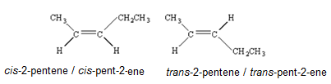 | 1  1  [2] | Award 1 mark for two correct formulae  Award 1 mark for two correct names
5 (c) (i) | CH₃CH₂CH₂CHCH₂ + HBr → CH₃CH₂CH₂CHBrCH₃  2-bromopentane | 1  1  [2]
5 (c) (ii) | Electrophilic addition  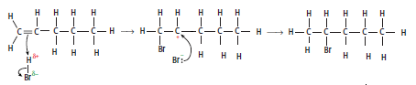 | 1 | For the mark both words are required
 | Curly arrow goes from the double bond towards H atom of the HBr molecule  Dipoles are shown on HBr molecule  Bond breaking in HBr molecule  Curly arrow from a lone pair of bromide ion towards to the positively charged carbon atom | 1  1  1  1  [5]
5 d (i) | 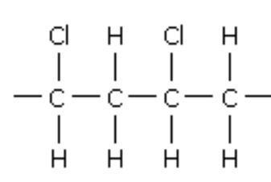 | [1]
5 d (ii) | not capable of being broken down by the action of living organisms | [1]

Question | Answer | Mark | Additional guidance
6 (a) (i) | The E_{a(cat)} is labelled to the left original E_{a}  The peak of their new curve is displaced to the left and higher than the original  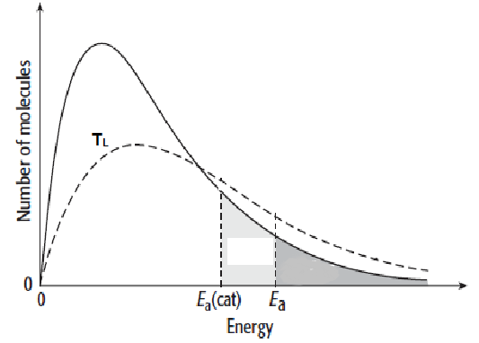 | 1  1  [2]
6 (b) (i) | k = 0.15  dm⁶ mol⁻² s⁻¹ | 1  1  [2] | accept mol⁻² dm⁶ s⁻¹
6 (b) (ii) | Exp 2 0.014 | [1]
6 (b) (iii) | Step 1 OR 2A + B → A₂B  The rate equation indicates that two particles of A (second order wrt A) and one particle of B (first order wrt B) in slowest step | [1]
6 (c) (i) | Concentration(s) of reactants and products remain(s) constant / do(es) not change  Forward rate = backward rate | 1  1  [2] | NOT “equal concentrations” and  NOT “concentration(s) is/are the same”  Ignore “dynamic”, “speed” “closed system”
6 (c) (ii) | Increase OR more OR larger | 1 | accept moves to left/to the reactants side
6 (c) (iii) | Pressure does not affect on K_{c}  K_{c} decreases | 1  1  [2]
6 (d) (i) | K_{c} =[SO₃]² / [SO₂]² [O₂]  [SO₂]² = [5.24/10]² / 68.0 x(3.82/10)  [SO₂] = 0.100 | 1  1  1  [3] | Award two marks for [SO₂]² = [5.24]² / 68 x(3.82)  [SO₂] = 0.100  Award one marks for [SO₂]² = [5.24]² / 68 x(3.82)
6 (d) (ii) | T₂ is lower than T₁  forward reaction is exothermic  at T₂ equilibrium position shifts to RHS | 1  1  1  [3]
7 (a) (i) | CH₃CO⁺  AlCl₄⁻ | 1  1  [2]
7 (a) (ii) | bond angle is 109⁰ | 1  1  [2] | ecf from (a)(i)  Accept a diagram when all dots or all crosses are used
7 (a) (iii) | 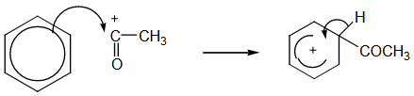 | 1  1  1  [3] | ecf from (a)(i)  arrow from the ring to the electrophile  partial ring in hexagon  arrow into hexagon
7 (b) (i) | 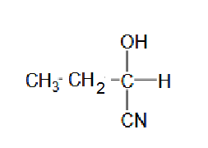 | [1]
7 (b) (ii) | 2-hydroxybutanoic acid | [1]
7 (b) (iii) | Nucleophilic addition | [1]
7 (c) (i) | Equal mixture of enantiomers / (optical) isomers/ 50:50 of both enantiomers | [1]
7 (c) (ii) | 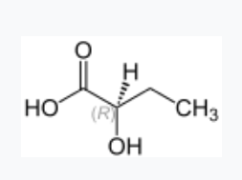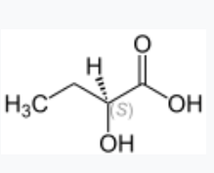 | 1  1  [2]
7 (c) (iii) | Each enantiomer differs in its  ‘pharmaceutical activity’ / one enantiomer  might be effective but the other could induce  serious side effects  minimises the risk of side effects / reduces  the patient’s dosage / the pure enantiomer is  more potent / has better therapeutic activity | 1  1  [2] | owtte

Question | Answer | Mark | Additional guidance
8 (a) (i) | 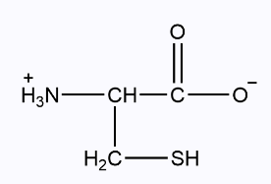 | [1]
8 (a) (ii) | 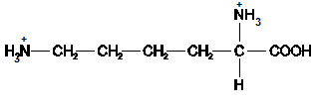 | [1]
8 (b) | 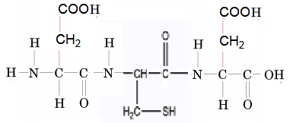 | 1  1  [2] | Correct formulae  Correct sequence  accept a structure drawn with a positive N terminal and a negative C terminal
8 (c) (i) | 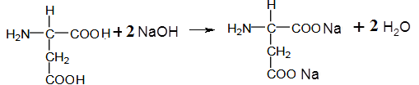 | 1  1  [2] | products correct  equation balanced
8 (c) (ii) |  | 1  1  [2] | products correct  equation balanced
8 (d) (i) | Disulfide linkage/bridge/bond/S-S | [1] | ignore covalent bond
8 (d) (ii) | Tertiary structure | [1]

Question | Answer | Mark | Additional guidance
9 (a) (i) | Tetramethylsilane/TMS/(CH₃)₄Si | [1]
9 (a) (ii) | δ= 4.1 peak is quartet as adjacent/next to/attached to CH₃  δ = 1.2 is triplet as adjacent/next to/attached to CH₂  at 1720 cm^{–1}in the IR spectrum – C=O group | 1  1  1  [3]
9 (b) | CH₃COOCH₂CH₃ | [1]
9 (c) | HCOOCH₂CH₂CH₃ Propyl methanoate  HCOOCH(CH₃)₂ Methylethyl methanoate  CH₃CH₂COOCH₃ Methyl propanoate  Two marks for correct structural formulas  and  Two marks for correct names | 1  1  1  1  [4] | Accept any two

BLANK PAGE

